Modeling and Analysis of Contactless Electric Vehicles Charging with Solar Energy

Raviteja, Yashwanth, Yashasri, Mrudula, Kallemudhin

Electrical & Electronics Engineering, KU College of Engineering & Technology,

Kakatiya University Campus, Warangal, India.

*Abstract*— The surge in Electric Vehicles (EVs) as an eco-friendly transportation solution has prompted a change in basic assumptions in charging infrastructure. This project presents a groundbreaking Smart Wireless Electric Vehicle Charging System that revolutionizes traditional charging paradigms by enabling EVs to charge seamlessly while in motion, drawing power from an innovative network of renewable energy sources, primarily solar energy. Built on the principles of Wireless Power Transfer (WPT) and Inductive Power Transfer (IPT), the system integrates charging coils within the road surface, strategically positioned to create a dynamic wireless charging corridor. These coils generate a magnetic field, inducing an electric current in corresponding coils integrated into the EV, fostering continuous wireless energy transfer. The novel aspect lies in integrating solar energy into the infrastructure, further enhancing the sustainability of electric mobility. The renewable energy source, primarily solar panels embedded along the road, harvests sunlight and converts it into electrical energy. This energy is seamlessly integrated into the wireless charging infrastructure, ensuring that the power supplied to EVs is derived from a clean and sustainable source. In this project, a few kW magnetic resonance wireless charging system for electric vehicles (EVs) is derived, and an explicit solution. The maximum power transmission efficiency (PTE) is above 90% in this system. By adjusting the duty ratio, this system adapts the dynamic change of the battery load and balances the current of the transmitting coil and receiving coil. At the same time, the charging power and PTE are also greatly increased.

Keywords— Externally chargeable hybrid vehicles, Electric Vehicles, Smart Grid, Wireless charging.

# Introduction

With the increasing emphasis on energy and environmental issues, it has become essential to develop electric vehicles (EVs) that can mitigate air pollution emissions, save energy, and reduce our dependence on fossil fuels. However, the current EVs use charging cables and plugs for direct contact charging, which can be inflexible and pose significant safety risks such as electric shock, electric leakage, spark production, and electric erosion wear. The security of EV charging needs to be improved.

Wireless charging for EVs is an innovative solution that uses electromagnetic fields to transfer energy from the charging station to the EV without any physical contact. This technology eliminates the need for cables and plugs, making it safer and more convenient. The research on wireless charging technology for EVs is currently underway, with colleges and enterprises investing substantial resources in charging topology, modeling, simulation, and hardware experiments. Major automobile manufacturers, including BMW and Toyota, have already developed prototypes of wireless charging systems for EVs.

Despite its potential, wireless charging technology for EVs is still in its infancy, and several challenges need to be addressed. One of the major hurdles is charging efficiency, which is currently lower than that of cable charging. While traditional cable charging can achieve over 97% efficiency, wireless charging can only attain 90% efficiency. Other issues include the electromagnetic coupling mechanism, power control, and electromagnetic environment issues.

To address these issues, a magnetic resonance wireless charging scheme has been designed. This wireless charging system uses power electronic transformation technology to balance current, improve power transmission efficiency, and solve the problem of dynamic access battery load. It has the potential to revolutionize EV charging by providing a safer, more convenient, and reliable solution for powering EVs.

# requirement for technology

The rapid advancements in technology have led to the development of a remarkable wireless charging system that has the potential to revolutionize the world of electric vehicles and smart infrastructure. This innovative technology has multiple potential applications, including in public transportation, logistics, and personal vehicles.

The integration of wireless charging technology into vehicles enables the continuous charging of the vehicle's battery, which significantly increases the range of the vehicle. Moreover, this technology eliminates the need for large and heavy batteries, thereby reducing the overall weight of the vehicle. This, in turn, provides a more sustainable and efficient transportation ecosystem that is kinder to the environment.

The wireless charging system is adaptable to different environments and future technological advancements, making it an essential solution for the electrification of transportation networks worldwide. Wireless charging technology can be deployed in a variety of locations, including public roads, highways, and parking lots. This adaptability makes it a crucial advancement that can help decrease carbon emissions and promote the adoption of electric vehicles, ultimately leading to a cleaner and healthier environment for everyone.

Wireless charging technology is highly efficient and safe to use. It uses the principle of magnetic resonance, which allows for the wireless transfer of energy between two objects. Additionally, the technology is designed to automatically stop charging when the battery is full, preventing overcharging and prolonging the battery's lifespan.

The advent of wireless charging technology is a significant development that has the potential to revolutionize the transportation industry. By reducing the carbon footprint of transportation and promoting the adoption of electric vehicles, it represents a crucial step toward a cleaner and healthier environment for all. With the potential to redefine the way we think about transportation, wireless charging technology is a highly promising innovation that holds great promise for the future.

# MODELING OF EV’S CHARGING SYSTEM

The comprehensive architecture of the wireless charging system used in electric vehicles (EVs) is illustrated in Figure 1. This system comprises several crucial components that work together to enable wireless charging.

Firstly, the AC input, which operates at 50Hz, is rectified through an AC-DC converter and then passed to a high-frequency inverter. The inverter generates an alternating current whose frequency matches the resonance frequency of both the transmitter and receiver. The transmitter and receiver use an inductor and compensation capacitor in series, which form the core of the charging mechanism.

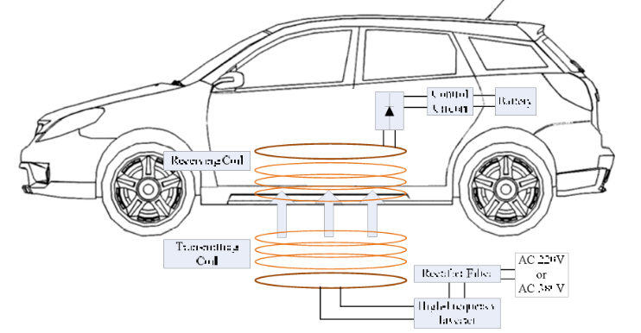

* Fig-1:Electric vehicle charging system schematic diagram

The rectifier control circuit is responsible for converting the power received by the receiver into DC power, which is suitable for charging the battery. A DC voltage regulator may also be added to the circuit to maintain stable voltage during charging.

The EV's wireless charging system's resonance frequency can be adjusted to meet varying power levels, power transmission efficiency (PTE) requirements, and transmission distances. This flexibility allows for optimization based on specific operating conditions.

The transmitter and receiver coils are usually designed using flat spiral coil configurations because they are space-saving and easy to install. The flat spiral coil's turn spacing remains constant, which simplifies the design process. The resonance frequency of the transmitter and receiver is determined by the coil's inductance (L) and capacitance (C), which dictate the system's overall frequency (f) using the formula

f=1/2π√LC.

In order to reduce the axial space as much as possible and facilitate installation, EVs wireless charging systems usually employ flat spiral coils. This paper presents a design for a flat spiral coil, as shown in Figure 3. The turn spacing of a flat spiral coil is constant, and the coil's shape is defined by the number of turns N and the turn spacing the outer diameter Dmax, and the inner diameter Dmin..

# WIRELESS ENERGY TRANSMISSION PLAN

The Wireless energy transfer, once a concept relegated to the realm of science fiction, has rapidly become a tangible reality with profound implications for various industries and everyday life. This essay explores the different schemes and advancements in wireless energy transfer technologies, highlighting their significance and potential impact.

One of the pioneering methods in wireless energy transfer is inductive coupling. This scheme involves the use of coils to create a magnetic field, allowing energy to be transferred from a transmitter to a receiver without physical contact. Inductive charging pads for smartphones and electric toothbrushes exemplify the practical applications of this technology, providing convenient and cable-free charging solutions.

Building upon the principles of inductive coupling, resonant inductive coupling has emerged as a more efficient and versatile method. By tuning the transmitter and receiver coils to resonate at the same frequency, resonance-based systems achieve higher efficiency and longer-range energy transfer. This advancement has facilitated the development of wireless charging systems for electric vehicles, enabling efficient charging without the need for cumbersome cables or connectors.

Beyond inductive coupling, other wireless energy transfer schemes offer unique advantages and applications. Microwave power transmission, for instance, leverages microwave radiation to transmit energy over long distances. This technology has been explored for space-based solar power systems, which could provide clean and renewable energy to Earth by beaming solar power collected in space.

Radiofrequency (RF) energy harvesting presents another promising avenue for wireless energy transfer. By capturing ambient RF signals, such as Wi-Fi or cellular transmissions, and converting them into electrical energy, RF energy harvesting enables self-powered IoT devices and wireless sensors. This approach holds significant potential for powering the proliferation of interconnected devices in the Internet of Things ecosystem.

Moreover, laser power transmission represents an innovative method for wireless energy transfer. By directing laser beams toward photovoltaic cells, light energy is converted into electrical energy, enabling efficient and directed power transmission. Laser power transmission has applications in powering remote sensors, space-based power systems, and even wireless charging of electronic devices. wireless energy transfer technologies have evolved rapidly, offering diverse methods for transmitting power without physical connections. From inductive coupling to microwave power transmission and beyond, these advancements hold promise for revolutionizing various industries and enhancing everyday convenience. As research and development in this field continue, wireless energy transfer is poised to play an increasingly significant role in shaping the future of energy distribution and consumption..

## System Design

The use of electric vehicles (EVs) is gaining momentum globally as a promising solution to reduce greenhouse gas emissions and dependence on fossil fuels. As the EV market grows, the demand for efficient and convenient charging solutions has become increasingly important. In response, wireless charging systems for electric vehicles have garnered significant attention due to their potential to enhance user convenience and streamline the charging process. This essay aims to provide a detailed overview of the design of the system topology for an electric vehicle wireless charging system, outlining the key components and their integration to create a functional and efficient charging infrastructure.

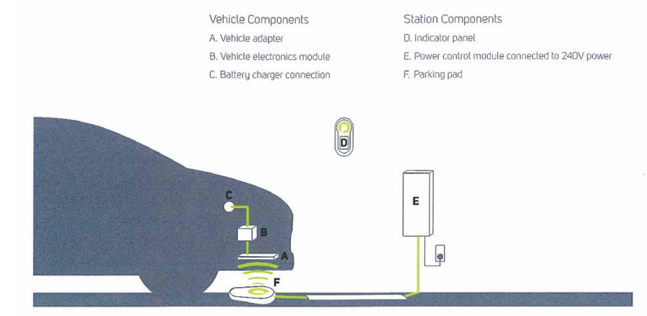

The system starts with a power source, which can be the electrical grid or renewable energy sources such as solar or wind. Before wireless transmission, the electrical energy must undergo conversion and regulation to match the requirements of the charging system. This involves using converters and regulators to ensure that the voltage and current levels are suitable for wireless transmission and compatible with the EV's charging system.

The heart of the wireless charging system comprises the transmitter and receiver units. The transmitter unit, typically installed in a charging pad on the ground, generates an electromagnetic field to wirelessly transmit electrical energy to the EV. It consists of a transmitting coil and associated electronics for field generation and control. Conversely, the receiver unit, installed in the EV, receives the transmitted energy and converts it into usable power to charge the vehicle's battery pack. The receiver unit includes a receiving coil and electronics for rectification, regulation, and safety features such as temperature monitoring and overcharge protection.

Effective communication between the transmitter and receiver units is essential for efficient charging and safety. A communication interface facilitates the exchange of information such as power transfer status, charging requirements, and safety signals. Common communication protocols used include Bluetooth, Wi-Fi, or proprietary protocols, enabling bidirectional communication for optimal charging performance.

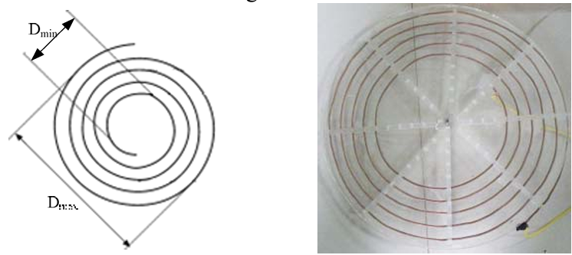

Safety is paramount in an EV wireless charging system to protect both the vehicle and the charging infrastructure. Various safety features should be integrated, including overcurrent protection, overvoltage protection, temperature monitoring, and fault detection. These features ensure safe and reliable operation of the charging system, minimizing the risk of accidents or damage to the EV.

The seamless integration of these components is essential to create a functional and efficient wireless charging system. A control and monitoring system oversees the operation of the charging system, managing power flow, detecting faults, and optimizing charging performance. Additionally, grid connection enables the system to draw power from the electrical grid and potentially enable vehicle-to-grid (V2G) applications, enhancing the flexibility and sustainability of the charging infrastructure.

Designing the system topology of an electric vehicle wireless charging system involves integrating various components to create a safe, efficient, and user-friendly charging infrastructure. By leveraging advanced technologies and effective communication protocols, wireless charging systems offer a promising solution to meet the growing demand for convenient and sustainable EV charging solutions. As the EV market continues to evolve, further innovations in wireless charging technology will play a crucial role in shaping the future of transportation and energy systems.

## Charging circuit Modeling

In battery modeling, it is important to take into account various factors that can affect battery performance. However, this study aims to simplify the analysis by focusing on a voltage source model and equivalent series resistance. This approach considers the power supply as a constant voltage source, disregarding its internal resistance.

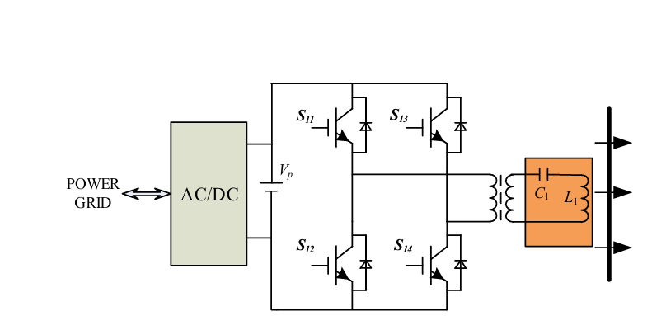

The study also proposes a buck chopper DC-DC converter as the means for battery charging. This type of converter is effective for its high efficiency and low cost. The equivalent circuit for this system is shown in Figure 1, and it includes several key components.

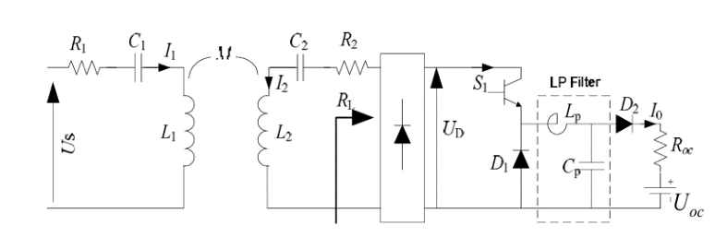



Firstly, R1 and R2 represent the equivalent series resistance of coils at high frequencies. This is important to consider because high-frequency resistance can have a significant impact on battery performance. Secondly, the mutual inductance between the transmitting and receiving coils is represented by M. This is a key factor in determining the efficiency of power transfer.



I1 stands for the RMS of the transmitting coil current, while I2 represents the RMS of the receiving coil current. This is important to measure because the current flow affects the amount of power that is transferred. I0 indicates the battery charging current, which is the amount of current that is used to charge the battery.



UD signifies the RMS of the equivalent voltage after rectification. This is important because it represents the amount of voltage that is available for charging the battery. ROC stands for the equivalent resistance of the battery, and UOC denotes the equivalent voltage of the battery. These two factors are important in determining how much power is needed to charge the battery.



Finally, D represents the duty ratio of the Buck chopper. This is important because it determines how much power is transferred to the battery at any given time. Overall, this study offers a detailed analysis of battery modeling and provides valuable insights for future research.

## Battery Equivalent Resistance Analysis

The effective series resistance (ESR) of a battery load accessed system is dependent on a variety of parameters. While the parameters of the battery itself are important, the operating frequency, coil parameters, input voltage, and the duty ratio of the DC-DC converter also play a crucial role. In a recent study, the researchers found that when the system parameters are identical to those in Table 1, the ESR will vary depending on the duty ratio. The variation curve is depicted, and it is evident that when D=0.55, the ESR is 1 to 2 times higher than when D=0.85. This discrepancy can have a significant influence on the impedance-matching design and control for the system.

If the system impedance is designed based on a duty ratio of 0.55, any change to 0.85 can cause difficulties with frequency tracking and starting the system. Furthermore, the ESR of the battery gradually decreases with a rise in Us, particularly in the low voltage portion. Illustrates the curve of charging power and Power Transfer Efficiency (PTE) under different duty ratios. The curves show that a higher PTE can be achieved when the duty ratio is high, and the charging power of the system is low. However, the variation rate of the system charging power with Us is lower than the low duty ratio.

As the charging power increases, the efficiency of the system decreases with an increase in the duty ratio. When the charging power reaches a certain level, the PTE and charging power under a high-duty ratio are lower than under a low-duty ratio for the same Us. Therefore, the regulation of charging power can be achieved by adjusting the duty ratio, and the choice of duty ratio can be determined based on practical demand.

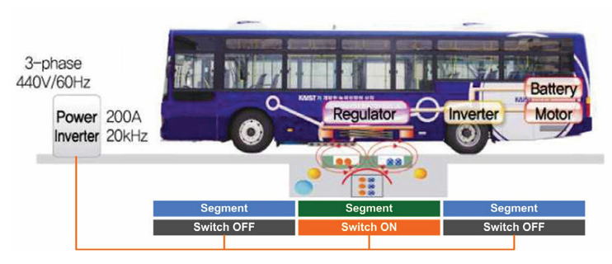

The main concentration of this DC link operator is to sustain steady voltage. The evaluation is created for recommendation value and also the actual market value of currents at dc hyperlink and also the error is sent out to FLC operator which moderates the current at dc-link. The FLC controller's result is considered as direct-axis of recommendation present, Id_ref, for the inner current controller.

# MODELING OF CONVERSION SYSTEMS

When it comes to wireless charging electric vehicles, there are several components that work together to make it all happen. Let's take a closer look at each of these components and their specific functions.

First and foremost, there's the solar panel. This component uses photovoltaic cells to collect direct sun radiation and then convert it into electrical energy. This

energy is then used to charge the battery, which stores the electrical energy in the form of DC power.

A regulatory circuit is also required in this system. This circuit regulates the power and converts the DC power to AC power. Additionally, a transformer is used to adjust the voltage levels to ensure that the charging process is safe and efficient.

The transmitter is another important component in this system. It's also known as the charging pad or ground pad and is responsible for generating an alternating magnetic field that induces an AC in the receiver pad to wirelessly transfer energy to the electric vehicle battery.

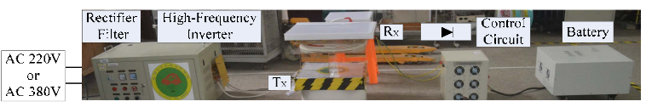

On the underside of the electric vehicle, there's the receiver pad. This pad is responsible for receiving the alternating magnetic field generated by the charging pad. Finally, a rectifier circuit, also known as an AC-to-DC converter, is used to convert the AC power to DC power that can be used to charge the battery.

An ATMEGA controller, which is an 8-bit AVR RISC-based controller that executes powerful instructions in a single clock cycle, is also used in the system. This controller measures the input voltage and displays it on an LCD, making it easy to monitor the charging process.

Finally, a voltage regulator is used in the system. This electronic device maintains a constant output voltage despite changes in the input voltage or load. This ensures that the charging process is consistent and safe for both the vehicle and the charging system.

## Working

The process of converting solar energy into usable electric power is a complex one. The power generated by solar panels is typically DC, or direct current, which is then stored in a battery. However, most electrical appliances and devices require AC, or alternating current, to function. To convert DC power to AC power, a regulatory circuit is used. This circuit includes a transformer that steps up or steps down the input voltage levels, depending on the requirements of the device.

In an effort to make electric vehicles more convenient, researchers have developed a wireless charging system that uses an inductive power transfer (IPT) principle. This system consists of a charging pad that is installed underneath the road pavement and a receiver coil that is installed on the underside of the electric vehicle. When the electric vehicle passes over the charging pad, it receives a magnetic field through the receiver coil, which is converted to DC power to charge the battery using a power converter.

# MATLAB RESULTS

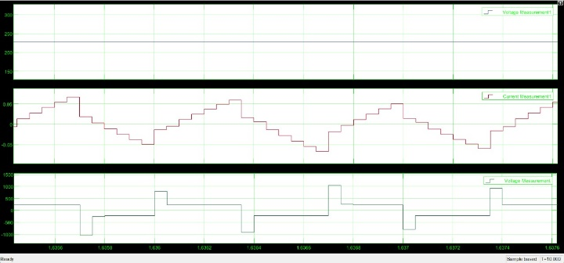

Based on the figure provided, the waveform displayed at the top represents the output voltage generated from the solar energy source. This output voltage is then passed through a high-frequency inverter, which converts direct current (DC) into alternating current (AC). The conversion process results in the transformation of the constant amplitude voltage of the solar energy into a sinusoidal or nearly sinusoidal voltage waveform with a high frequency.



In order to convert voltage from DC to AC, a series of switches need to be triggered at precise time intervals. The input pulses shown above are provided by a high-frequency inverter, which generates pulses at a rapid rate in order to ensure accurate and efficient conversion of the voltage signal. This process is crucial in many applications, such as power generation and distribution, as it allows for the safe and effective transfer of energy between different systems and components.

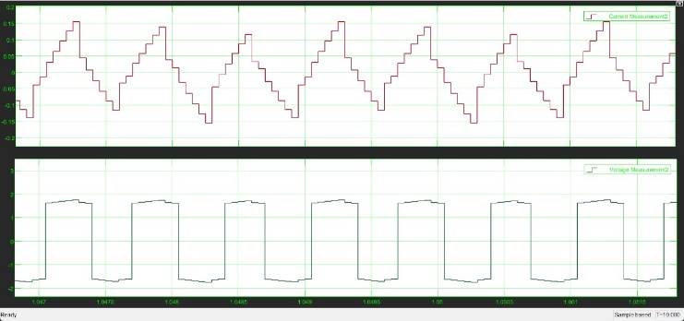

After being converted, the voltage is then fed to the transmitted circuit. This circuit is responsible for transmitting the voltage to the receiver circuit in the vehicle. Once the transmission is complete, the wave forms produced during the process are shown in the figure above. It is worth noting that the transmission process is crucial to ensure that the intended voltage is correctly received by the receiver circuit in the vehicle.

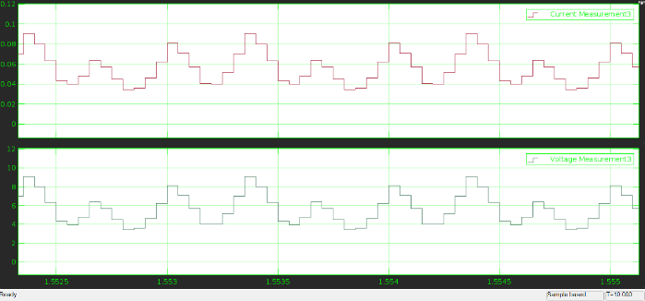

# CONCLUSION

This paper has presented the advent of wireless charging for electric vehicles, has provided an unprecedented level of convenience, safety, and reliability that was previously unheard of. One of the major benefits of this technology is that it eliminates the need for charging cables, thereby reducing the risks associated with cable exposure. This charging process is not only time-saving, but it also eliminates the need for charging stations, making it a more cost-effective solution for electric vehicle owners.

Apart from its convenience, this charging system also has a positive impact on the environment. Since it draws its power from solar energy, it significantly reduces the use of fossil fuels, which is a major contributor to greenhouse gas emissions and climate change. By promoting a sustainable way to power electric vehicles, this technology is helping to reduce the carbon footprint of transportation and support the transition to a cleaner, greener future.

The wireless charging system works on the principle of induction power transfer, which involves the transfer of energy wirelessly between magnetically coupled coils. This process ensures that the electric vehicle's battery is charged efficiently and effectively, without any need for direct contact between the charger and the vehicle. Overall, the wireless charging technology is a game-changer for electric vehicles, providing a safer, more convenient, and eco-friendly solution for powering up.

##### References

1. DOI: 10.1109/WoW.2017.7959391 IEEE PELS Workshop on Emerging Technologies: Wireless Power Transfer (WoW)
2. DOI: 10.1109/GreenTech56823.2023.10173788 2023 IEEE Green Technologies Conference (GreenTech)

[3] Z. Ye, Y. Sun, Z. Wang, C. Tang, and Y. Su, "An Optimization Method of Coil Parameters for Wireless Charging System of Electric Vehicle," IEEE PELS WORKSHOP ON EMERGING TECHNOLOGIES: WIRELESS POWER (2016 WOW), pp. 221-223, 2016.

[4] C. C. Mi, G. Buja, S. Y. Choi, and C. T. Rim, "Modern Advances in Wireless Power Transfer Systems for Roadway Powered Electric Vehicles," IEEE Transactions on Industrial Electronics, vol. 63, pp. 6533 6545, 2016.

[5] Y. Sun, H. Zhang, A. P. Hu, C. Tang, and L. Xiang, "The Recognition and Control of Non-ideal Soft-Switching Frequency for Wireless Power Transfer System Based on Waveform Identification," IEEE Transactions on Power Electronics, vol. 32, pp. 6617-6627, 2017.

[6] D. T. Nguyen, E. S. Lee, B. G. Choi, and C. T. Rim, "Optimal Shaped Dipole-Coil Design and Experimental Verification of Inductive Power Transfer System for Home Applications," in Annual IEEE Applied Power Electronics Conference and Exposition (APEC), 2016, pp. 1773-1779.

[7] X. L. Huang, W. Wang, and L. L. Tan. "Technical Progress and Application Development of Magnetic Coupling Resonant Wireless Power Transfer". Automation of Electric Power Systems, vol. 41, pp. 2-14, 2017.

[8] Z. Bi, T. Kan, C. C. Mi, Y. Zhang, Z. Zhao, and G. A. Keoleian, "A review of wireless power transfer for electric vehicles: Prospects to enhance sustainable mobility," Applied Energy, vol. 179, pp. 413-425, 2016.

[9] K. Rajashekara, "Present Status and Future Trends in Electric Vehicle Propulsion Technologies," IEEE Journal of Emerging and Selected Topics in Power Electronics, vol. 1, pp. 3-10, 2013.

[10] F. Musavi and W. Eberle, "Overview of wireless power transfer technologies for electric vehicle battery charging," IET Power Electronics, 2014.

[11] W. Guo, H. Bai, G. Szatmari-Voicu, A. Taylor, J. Patterson, and J. Kane, "A 10kW 97%-efficiency LLC resonant DC/DC converter with wide range of output voltage for the battery chargers in Plug-in Hybrid Electric Vehicles,", 2012, pp. 1-4.

[12] L. Lu, X. Han, J. Li, J. Hua, and M. Ouyang, "A review on the key issues for lithium-ion battery management in electric vehicles," Journal of Power Sources, 2013.

[13] Miller, John M., and Xiaodong Shi. "Practical and Implementation Issues of Wireless Power Charging of EV’s." Newsletter 2016 (2016).

[14] L. L. Tan, X.L. Huang, H. Huang, Y. W. Zou, Li. H, "Transfer efficiency optimal control of magnetic resonance coupled system of wireless power transfer based on frequency control." Science China Technological Sciences vol. 54, pp. 1428-1434, 2011